The Field of Prosperity
Where Supply Exists Before It Takes Form

True prosperity is not money alone.
It is belonging to a benevolent Intelligence
that knows how to care for what it creates.

In this journey, you learn to stand in that field—
With words from a Divine Higher Awareness—
where supply exists as presence before it appears as form.

This is the difference between words born of lack
and words spoken from union.
Creation flows from union, not striving.

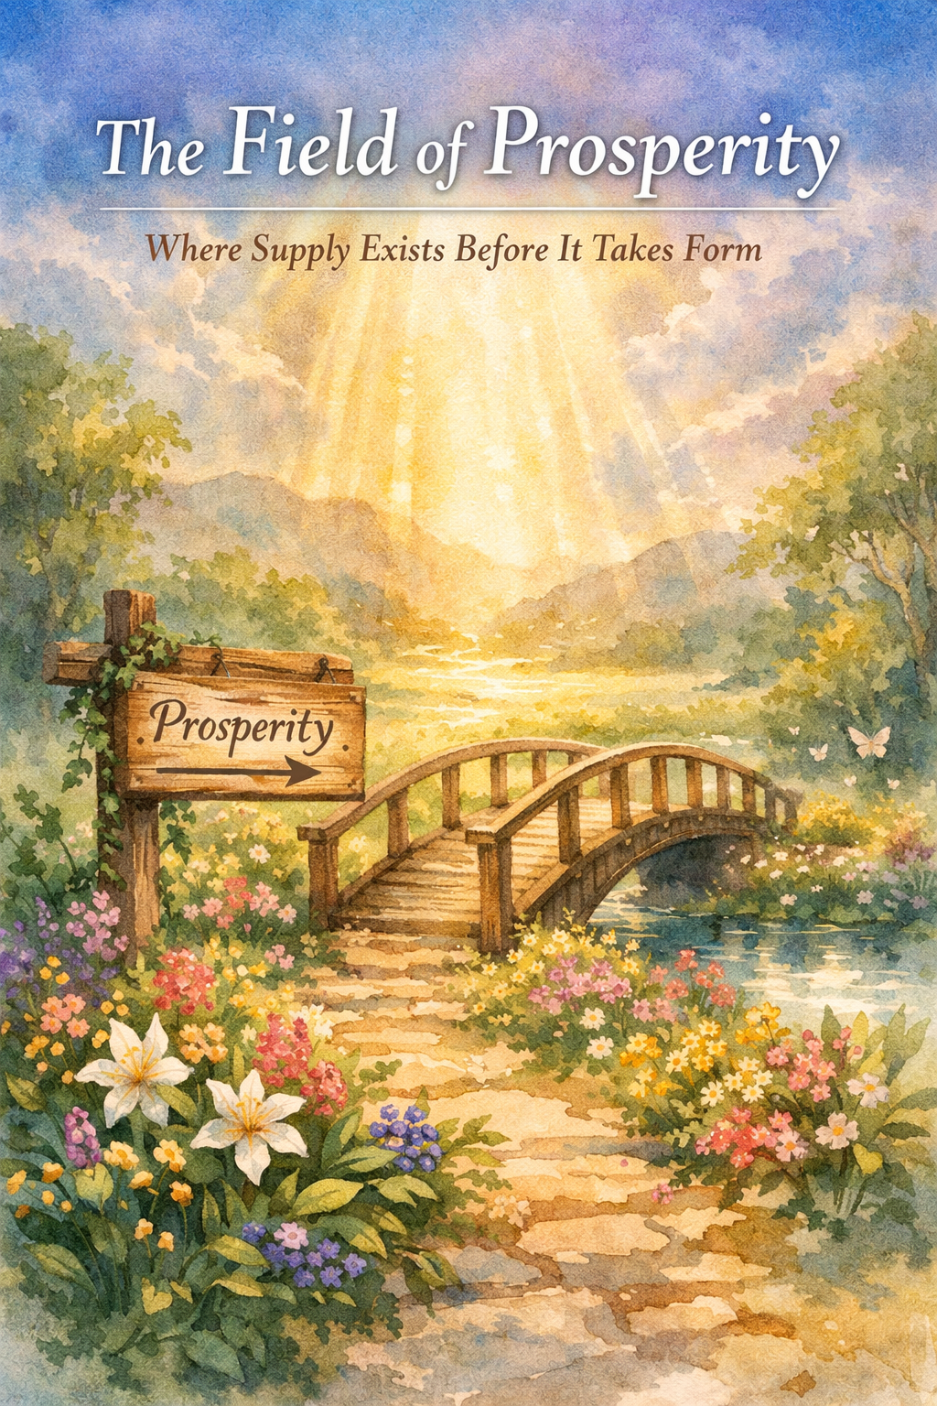

Core Teaching on Prosperous Provision
Faith is not hope or effort — faith is alignment with what already exists in God’s provision. Victory is not achieved; it is entered into through believing and speaking in harmony with divine truth.

Key Principles
- Faith operates by speaking agreement with God’s Word
- Words are containers of spiritual power
- Faith does not deny appearances; it supersedes them
- Victory is spiritual first, then visible
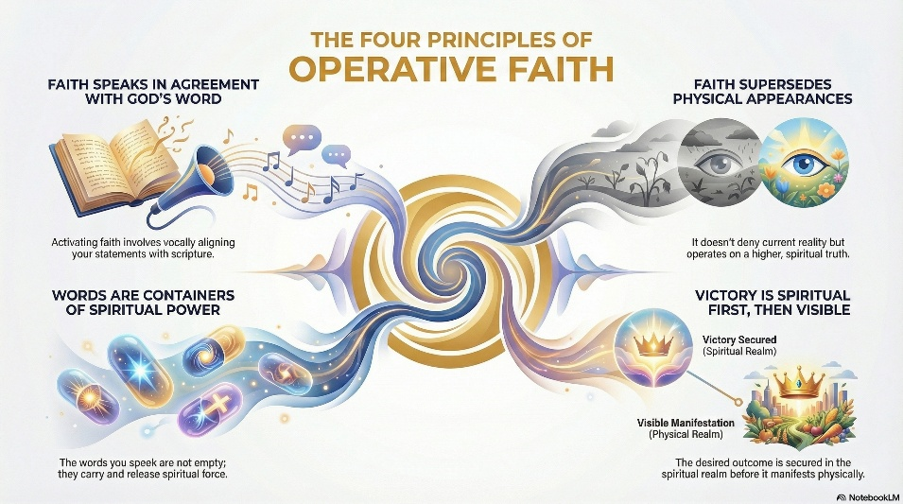

Prosperity Angle
Prosperity is a natural outcome of faith-consciousness, not a separate pursuit. When faith is active, supply responds automatically.

Essence for Your Course
Faith is resonance with Divine Reality.
This aligns with calling forth rather than striving — reality shifts because consciousness has already shifted.

Prosperity Angle
Money is treated as responsive energy, not a moral issue. It moves where spiritual authority is exercised.
Speech is the bridge between Spirit and form.
This fits perfectly with your emphasis on calling things that are not from higher awareness — not affirming from lack, but declaring from union.

Key Principles
- The outer world mirrors inner thought
- Anxiety blocks flow; trust restores it
- Divine Intelligence already knows how to provide
- Right thinking is not control — it is allowing



Prosperity Angle
Prosperity is a byproduct of peace and alignment, not effort or declaration alone.
Prosperity flows when the mind rests in Divine Intelligence.
Prosperity is fundamentally a state of consciousness, not an accumulation of money. Money is simply one expression of divine flow.

Key Principles
- God is infinite substance
- Supply is omnipresent but must be recognized
- Prosperity flows through circulation, gratitude, and openness
- You do not attract prosperity — you express it

Prosperity Angle
We should reframe wealth as spiritual circulation rather than acquisition.
You are not seeking supply — you are the channel of supply.
This dovetails beautifully with your top-down, Spirit-led model of life and creation

KEYS to Flow From Knowing I am Prosperity

- Prosperity begins in Divine Awareness
- Faith is alignment, not effort
- Speech is creative activation
- Supply responds to inner coherence
- You do not “get” — you allow and express
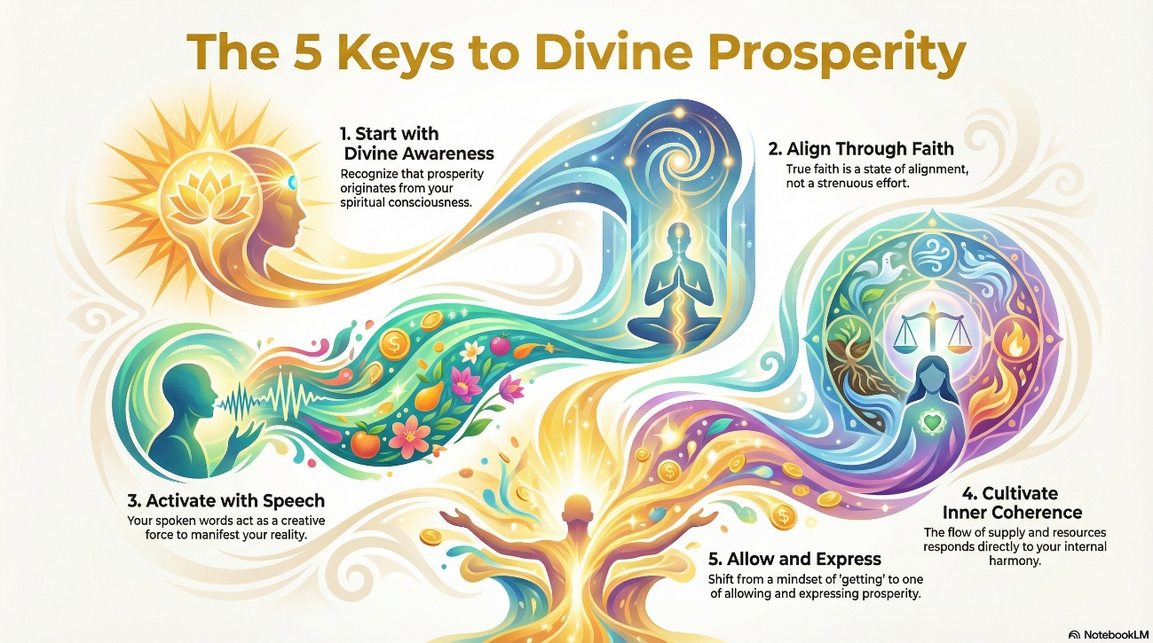

Course: “Living from Source Prosperity”
“Without forcing structure, a very organic flow appears”
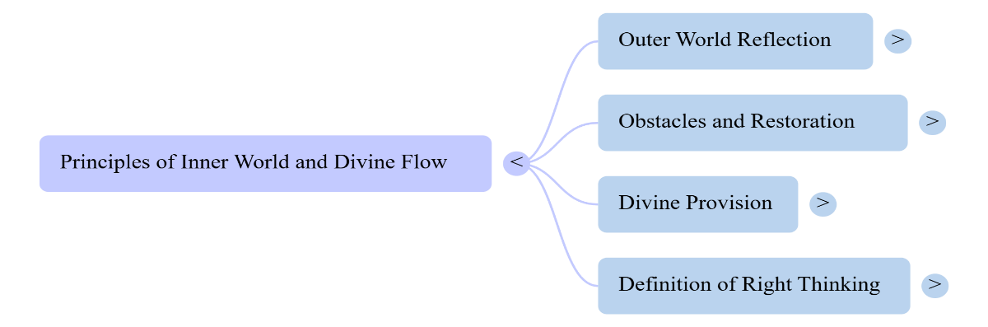
1. Prosperity as Consciousness
2. Right Thinking & Divine Trust
3. Faith as Alignment
4. Calling Forth Through the Word

Course Overview (12 modules):

Module 1 — The Field of Supply
Core idea: Supply is not “out there.” It’s a present field of Divine Substance you can live in and draw from.
Outcomes: Shift from scarcity-thinking to Supply-consciousness.
Practices: daily “Supply Recognition” pause; gratitude as field attunement.

Module 2 — Inner Alignment Before Outer Change
Core idea: You don’t force reality; you stabilize your inner state so reality can reorganize.
Outcomes: Reduce anxiety/strain; learn the feeling-tone of alignment.
Practices: “return to center” breath; release-control ritual; trust training.

Module 3 — Right Thinking as Sacred Stewardship
Core idea: Thoughts are not private—they’re creative instructions.
Outcomes: Replace reactive thought loops with directed awareness.
Practices: thought audit; “choose the higher interpretation”; mental rehearsal of the desired state.



Module 4 — Faith as Knowing
Core idea: Faith is not wishing; it’s inner knowing that what’s true in the Higher Field can become visible in form.
Outcomes: Move from hope → certainty; stop negotiating with appearances.
Practices: “decision point” exercise; evidence log (not of lack, but of movement).

Module 5 — The Creative Word
Core idea: Speech is the bridge from unseen to seen—a vibrational command that shapes form.
Outcomes: Learn how to speak from fulfillment instead of need.
Practices: short spoken decrees; “word hygiene” (stop undoing your work with fear-talk).

Module 6 — Calling Forth Without Denial
Core idea: You can acknowledge circumstances without bowing to them.
Outcomes: Stay grounded while holding the higher reality steady.
Practices: “Name it / Frame it / Claim it” method; compassionate truth statements.
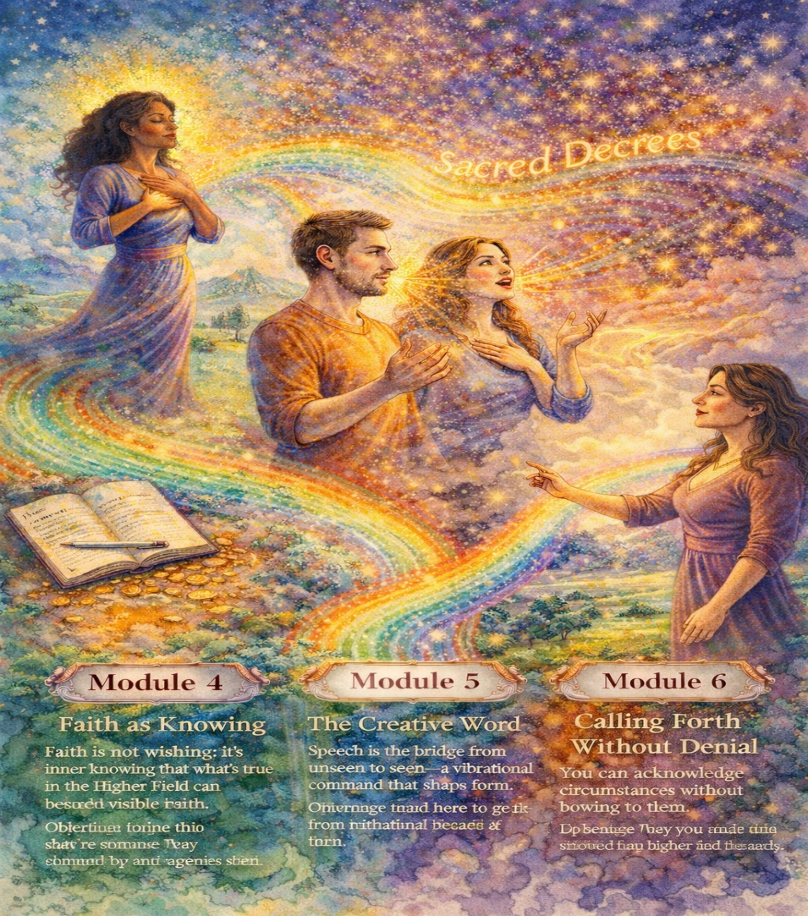

Module 7 — Receiving and Allowing
Core idea: Many people can declare, but they can’t receive. Receiving requires worthiness + openness + peace.
Outcomes: Remove internal blocks; increase receptivity.
Practices: worthiness repair; “open hands” visualization; micro-receiving challenges.

Module 8 — Circulation and Divine Flow
Core idea: Prosperity is movement—what you cling to contracts; what you circulate multiplies.
Outcomes: Rewire relationship with money/time/giving.
Practices: circulation plan (saving, spending, giving, investing); generosity without depletion.

Module 9 — Authority and Boundaries in the Material Realm
Core idea: You have the right to set terms: “This is the reality I consent to.”
Outcomes: Stop passive living; establish spiritual and practical boundaries.
Practices: authority statements; boundary scripts; “no more leakage” review.
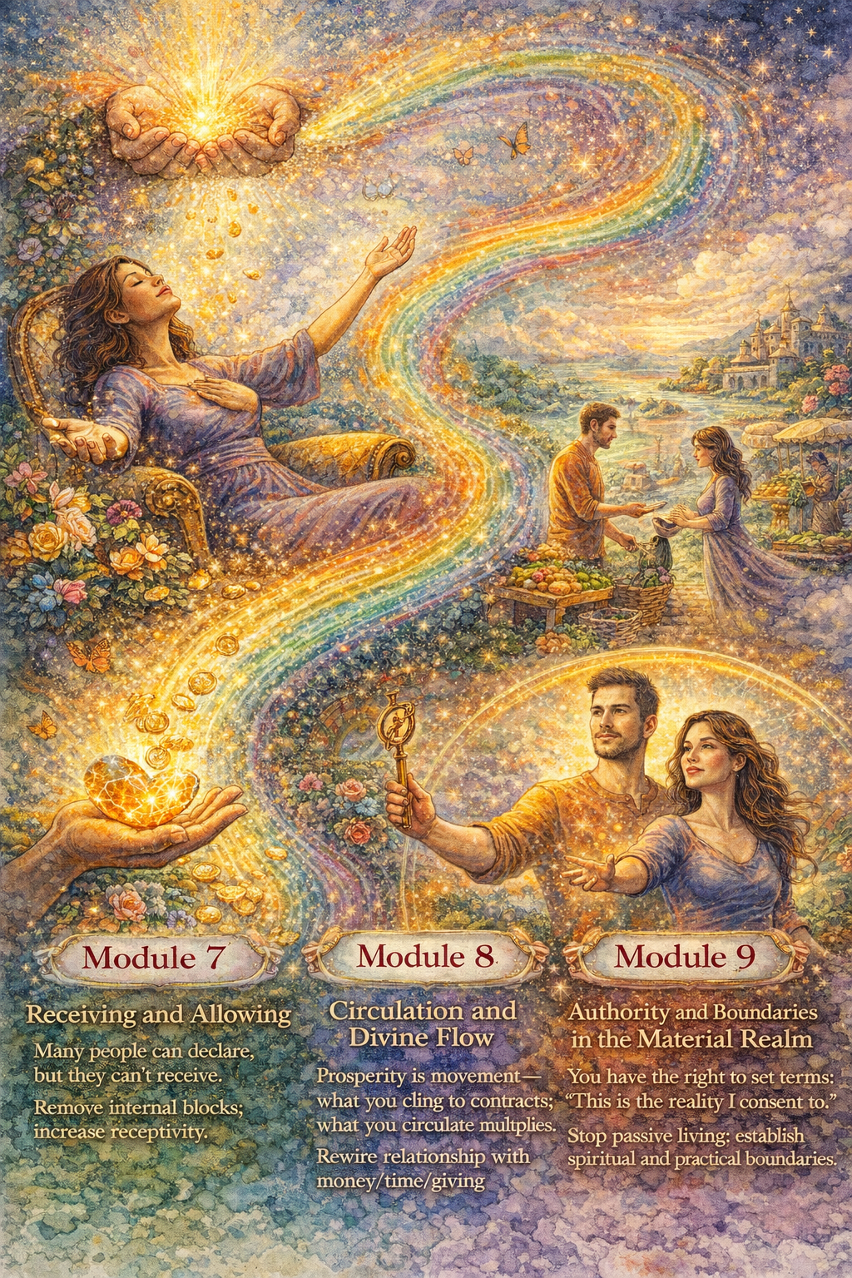

Module 10 — The Pattern of Manifestation
Core idea: Calling forth follows a pattern: Field → Alignment → Word → Action → Receiving → Stabilizing.
Outcomes: Recognize stages so you don’t quit too early or panic mid-process.
Practices: manifestation map; signs-of-movement checklist; avoid “delay despair.”

Module 11 — Embodied Prosperity
Core idea: Your nervous system must be able to hold what you’re calling in.
Outcomes: Expand capacity for more good without self-sabotage.
Practices: regulation tools; identity upgrade; “safe to have” somatic anchor.

Module 12 — Living as a Channel
Core idea: Prosperity is not just getting—it’s being a conduit for Divine expression in the world.
Outcomes: Align prosperity with purpose; service without martyrdom.
Practices: purpose vow; channel meditation; “prosperity with integrity” commitments.
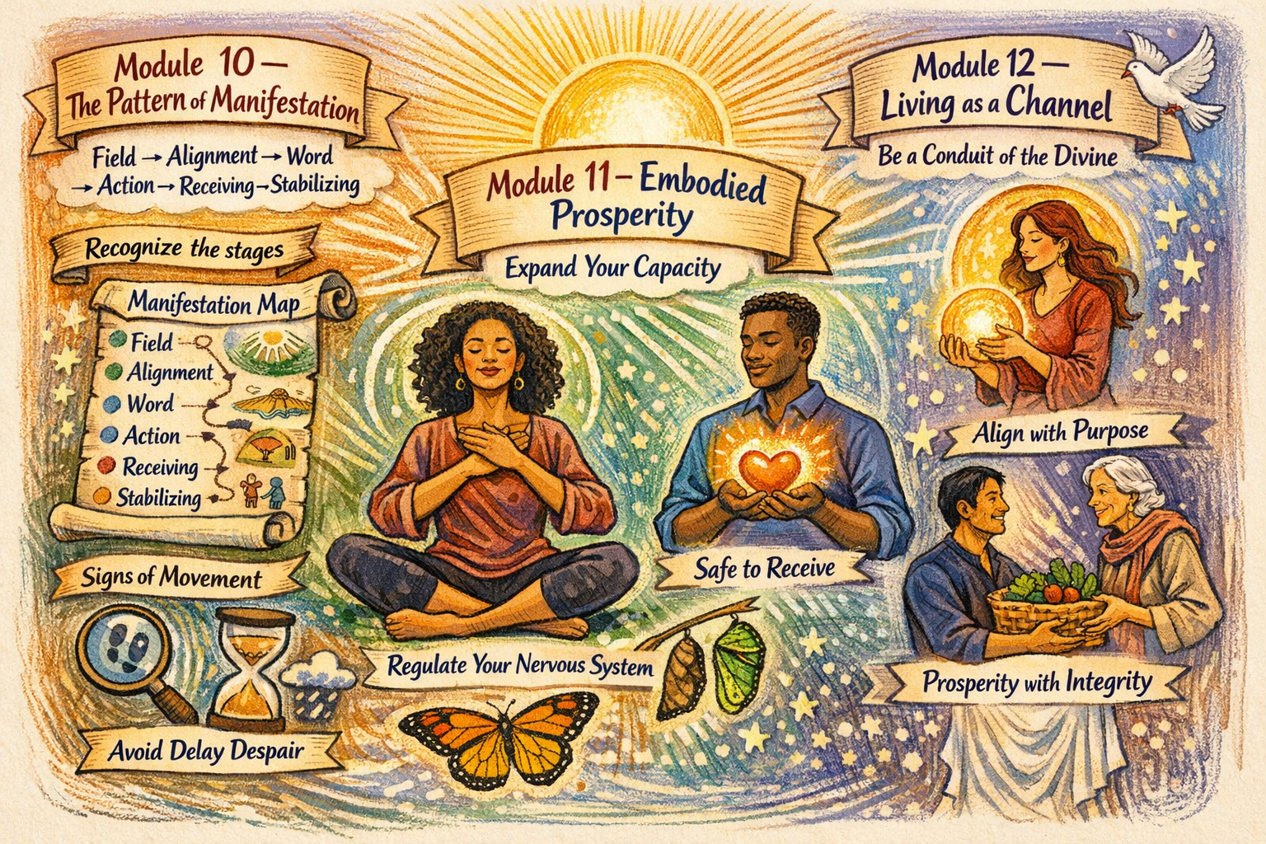

The Field of Prosperity
I release the burden of separation.
I return to the awareness of Divine support.
I allow supply to come in the ways that fit my highest good.
I am willing to receive what I can sustain.
I consent to a life of guided flow.
This journey will be practical.
It will be spiritual.
It will be grounded.
It will be safe.
Just cross over the bridge to a land of Higher Knowing
and your path to the greatest prosperity known.
I will guide you in your next course for higher knowledge.
